

e-Project
Report



Supervisor: Tran Minh Hoa
Curriculum: ACCP i7.1
Semester: 3 - HDSE
Batch Code: 0906E
Student : Tran Phan Quoc Hai
Nguyen Huu Sang
Pham Hong Tam
Nguyen Duc Viet





This is to certify that
Mr. TRAN PHAN QUOC HAI
has successfully designed and
developed
Campaign Information System

Submitted by:

TRAN PHAN QUOC HAI
Date of Issue: 08/12/2010
Authorized Signature: ___________

This is to certify that
Mr. NGUYEN HUU SANG
has successfully designed and
developed
Campaign Information System

Submitted by:

NGUYEN HUU SANG
Date of Issue: 08/12/2010
Authorized Signature: ___________

This is to certify that
Mr. PHAM HONG TAM
has successfully designed and
developed
Campaign Information System

Submitted by:

PHAM HONG TAM
Date of Issue: 08/12/2010
Authorized Signature: ___________

This is to certify that
Mr. NGUYEN DUC VIET
has successfully designed and
developed
Campaign Information System

Submitted by:

NGUYEN DUC VIET
Date of Issue: 08/12/2010
Authorized Signature: ___________

Table of Content

Content Page
1 . Problem Statement 5
2 . Customer Requirement Specification (CRS) 5
3 . Project Plan 6
4 . Site Map 7
5 . Use Case 8
5.1. Admin
5.2. Member
6 . Process Flowchart 9
6.1. Login 9
6.2. Change Password
6.3. Create Campaign
6.4. Update Campaign
6.5. Delete Campaign
6.6. Create Product
6.7. Update Product
6.8. Delete Product
7 . Entity Relationship (E-R Diagram) 10
8 . Table Design
9 . Program Design
10 . Document Design

1. Problem Statement

Arts is a stationary shop that sells arts, gift articles, greeting cards, dolls, files, hand bags, wallets, and as well some of the beauty products, etc…. As there is a lot of demand for the greeting cards, gift articles, hand bags, etc…. and in this busy world where one can hardly find time to go out for shopping and with the emerging new technologies where one can purchase products by placing an order through online by sitting at home/office either by credit cards or by VPP or through Cheque or through DD

2. CRS/Overview

Client/Project Undertaken: Online Shopping Cart

System Study:

2.1. List of inputs to the system.
- Username
- Password
- Campaign ID
- Campaign name
- Campaign Sale Target
- Campaign Estimated Budget
- Product category name
- Product ID
- Product name
- Product Price

2.2. List of outputs expected from the system.
- Report
- Campign name
- Campaign Sale Target
- Campaign Estimated Budget
- Product name
- Product Price

2.3. Overview of processes involved in the system.

2.4. Data Constraints/Triggers/Validation tables.

  - Hardware and software required for implementing the project.

  - Hardware
- A minimum computer system that will help you access all the tools in the courses is a Pentium 166 or better
- 128 Megabytes of RAM or better
- OS: Windows 2000 Server (or higher if possible)

  - Software
- Microsoft SQL Server 2005
- Microsoft Visual Studio 2005
- Microsoft .NET 3.0

3. Project Plan

3.1. Project Details

Name of the Client: ABC Insurance Company

- Date of the Project Plan: 20/12/2009

- Our understanding of the client organization

They are here to service all businesses and individuals of the community. Their mission is to assist the Insured in protecting their sources of investment capital and have peace of mind while doing business in order to sustain, develop and contribute further into the prosperity of the whole society by way of the following insurance solutions:
- A Comprehension insurance protection of your PROPERTY used for daily life and business operations.
- Maintaining the EARNING CAPACITY of the investors in the event of loss or damage caused by natural hazards, human errors and technological failures.
- Financial compensation in case of bodily injuries, death of PERSONAL belonging to the work force due to accident, illness or diseases.
- Source of legal assistance and consultancy in the case of the Insured incurring LEGAL LIABILITY to compensate arising from negligent acts when dealing with the public.

3.2. Project Initiation/Requirement Documents
Admin functions:
- Create User
- Assign User
- Edit Admin Information
- Export Report
- View Campaign Detail
- View Product Detail
- Change Password

Campaign Master function:
- Create Campaign
- EditCampaign
- Delete Campaign
- Edit Campaign Master Information
- Change Password

Product Master function:
- Create Product
- Create Product Category
- Edit Product
- Delete Product
- Edit Product Master Information
- Change Password

Employee functions:
- Edit Employee Information
- Change password
- View Campaign Detail
- View Product Detail

3.6. Quality Plan
- Review Activities (review meeting participants, and frequency).

- Testing Activities (Unit Test Plans, Integration Testing and Functionality Testing).
Group will do something such as test links, test function every meeting.
- Backup and recovery strategies (in case of disk crash and network failures).
After weekly, group will backup source code, database.

4. Site Map
Home Page

Login Page
Employee
Page
Registered Customer Page
Unregister Customer Page
Manage User
Page
Manage Product
Page
View Product Detail Page
Manage Feedback
Page
Change Password
Page
Edit Profile Page
Order Page
Manage Order
Page
Admin
Page
Register Page
Manage FAQ
Page
View Product Detail Page
Create , Update, Delete, Search Employee
Page
Create , Update, Delete, Search Product
Page

Answer, Delete
Feedback
Page
Create , Update Delete FAQ
Page

Update Order
Page

Create Feedback Page
View
Order
Detail Page
Create, Update Order
Page

5.Use Case

Change Password

View Campaign

View Product

Login

Export Report

Assign group

Delete
Member
Admin

Logout

Campaign
Master

Login

Add new Campaign
Edit profile
Change Password
Logout
Edit Campaign
Delete Campaign

Product
Master

Login

Add new Product
Edit Product
Delete Product
Change Password
Logout
Edit Profile

View Product
Employee

Login

Edit profile
Change Password
Logout
Edit profile

6. Process Flowchart

6.1. Login

Begin
End
Display
Login Page
Input
Username,
Password
User exists
Error
Message
Password
correct
Login
Successful

YES
YES
NO
NO

ADMIN

Login

Product
Master

m

D1
D2
D3
D1: Username, password
D2: D1
D3: + Login successful
+ Login fail

6.2 Log out

Begin
End

Log out
Display Login page

6.3. Change password

Begin
End
Display change password page
Input current password, new password
Current password correct
Error
Message

Change password successful

YES
NO

User
Change password

Product
Master

m

D1
D2
D3
D1: Current password, new password
D2: D1
D3: + Change successful
+ Change fail

6.4. Create Employee

Begin
End
Display Create employee page
Input ID, Name, Email, Address, Phone
ID
exists
Error
Message

Create employee successful

YES
NO

Admin
Create
Employee

Product
Master

m

D1
D2
D3
D1: ID, Name,Password,Email,…
D2: D1
D3: + Create successful
+ Create fail

6.5. Edit Profile

Begin
End
Display Edit employee page
Input ID, Name, Email, Address, Phone
ID
exists
Error
Message

Edit employee successful

YES
NO

User
Edit
Profile

Product
Master

m

D1
D2
D3
D1: Name, Email,…
D2: D1
D3: + Edit successful
+ Edit fail

6.6. Create New Campaign

Begin
End
Display Create new Campaign page
Input Campaign ID,Name,Object,
Estimated budget
Campaign ID exists
Error
Message

Create new Campaign Successful

YES
NO

Campaign
Master
Create
Campaign

Product
Master

m

D1
D2
D3
D1: Campaign ID, Name, Object,…
D2: D1
D3: + Create successful
+ Create fail

6.7. Update Campaign

Begin
End
Display Campaign Detail page
Input Campaign Name,Object,
Estimated budget
Campaign ID exists
Error
Message

Update Campaign Successful

YES
NO

Campaign
Master
Update
Campaign

Product
Master

m

D1
D2
D3
D1: Campaign Name, Object,…
D2: D1
D3: + Update successful
+ Update fail

6.8. Delete Campaign

Begin
End
Display Campaign Detail page
Campaign ID exists
Error
Message

Delete Campaign Successful

YES
NO

Campaign
Master
Delete
Campaign

Product
Master

m

D1
D2
D3
D1: ID
D2: D1
D3: + Delete successful
+ Delete fail

6.9. Create Product Category

Begin
End
Display Create Product Category page
Input Category ID,Name
Category ID exists
Error
Message

Create Product Category Successful

YES
NO

Campaign
Master

Create
Product
Category

Product
Master

m

D1: Product category name
D2: D1
D3: + Create successful
+ Create fail

6.10. Create Product

Begin
End
Display Create new Product page
Input Product ID,Name,Price
Product ID exists
Error
Message

Create new Product Successful

YES
NO

Product
Master
Create
Product

Product
Master

m

D1
D2
D3
D1: Product ID, Name,Price,…
D2: D1
D3: + Create successful
+ Create fail

6.11. Update Product

Begin
End
Display Product Detail page
Input Product new ID, Name, Price
Product ID exists
Error
Message

Update Product Successful

YES
NO

Product
Master
Update
Product

Product
Master

m

D1
D2
D3
D1: Product name, price,…
D2: D1
D3: + Update successful
+ Update fail

6.12. Delete Product

Begin
End
Display Product Detail page
Product ID exists
Error
Message

Delete Product Successful

YES
NO

Product
Master
Delete
Product

Product
Master

m

D1
D2
D3
D1: Product ID
D2: D1
D3: + Delete successful
+ Delete fail

7. Project Design

7.1 Database Design

a. Table Users

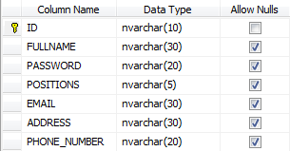

No. | Field Name | Description
01 | ID | ID of User
02 | FULLNAME | Name to login
03 | PASSWORD | Password to login
04 | POSITION | Position of User, ex: Admin, Employee…
05 | EMAIL | Email
06 | ADDRESS | Address
07 | PHONE_NUMBER | Phone number

b. Table Position

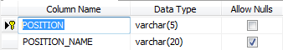

No. | Field Name | Description
01 | POSITION
02 | POSITION_NAME | Name of position

c. Table Campaign_Detail

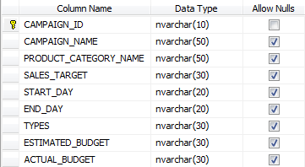

No. | Field Name | Description
01 | CAMPAIGN_ID | ID of campaign
02 | CAMPAIGN_NAME | Name of campaign
03 | PRODUCT_CATEGORY_NAME | Name of product category
04 | SALES_TARGET | The object insurance
05 | START_DAY | The date campaign start
06 | END_DAY | The date campaign finish
07 | TYPES | The types of advertisement
08 | ESTIMATED_BUDGET | The virtual budget
09 | ACTUAL_BUDGET | The actual budget

d. Table Product_Detail

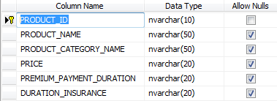

No. | Field Name | Description
01 | PRODUCT_ID | ID of product
02 | PRODUCT_NAME | Name of product
03 | PRODUCT_CATEGORY_NAME | Name of product category
04 | PRICE | Price of insurance package
05 | PREMIUM_PAYMENT_DURATION | The period of time to
06 | DURATION_INSURANCE | Duration of insurance package

e. Table Product_Category

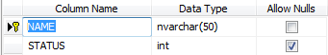

No. | Field Name | Description
01 | NAME | Name of product category
02 | STATUS | Status of product category: 1 – used, 0- unused

7.2 Entity Relationship Diagram (E-R Diagram)

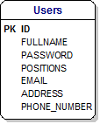
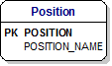
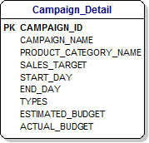
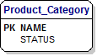
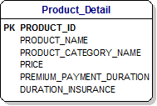

7.3. Class Object Diagram

a. User
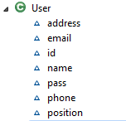

b. Category

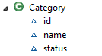

c. Object Campaign

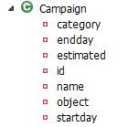

d. Object Product
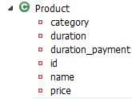

8. Graphic User Interface

8.1 Application Sreen

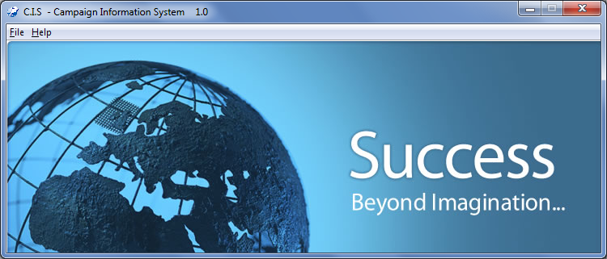

Introdution Form

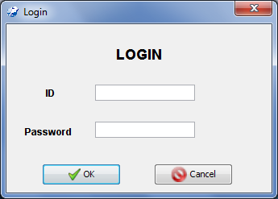

Login Form

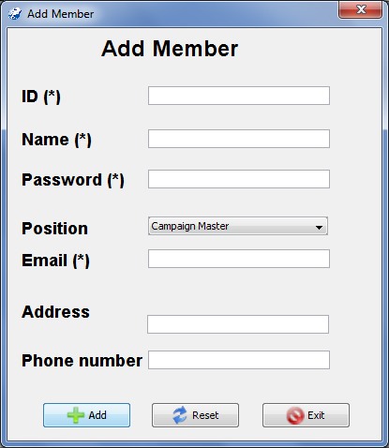

Add Member Form

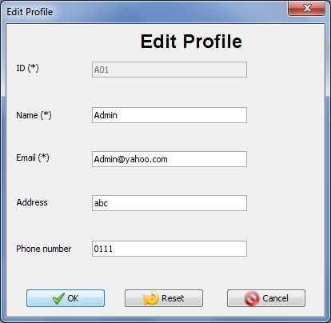

Edit Profile Form
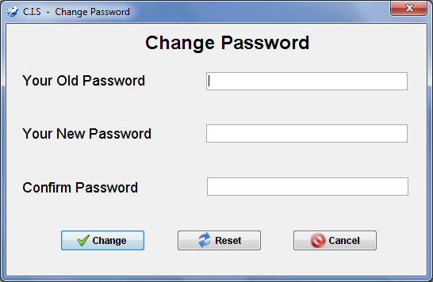

Change Password Form

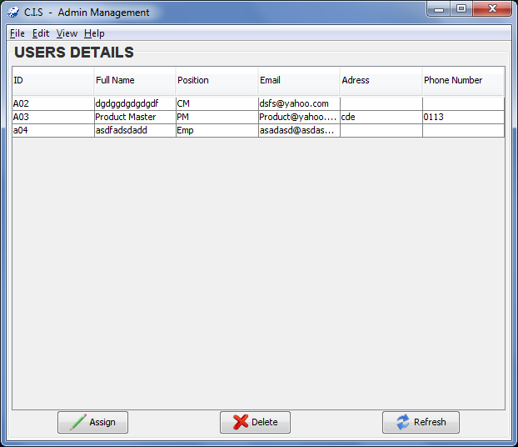

Admin Form

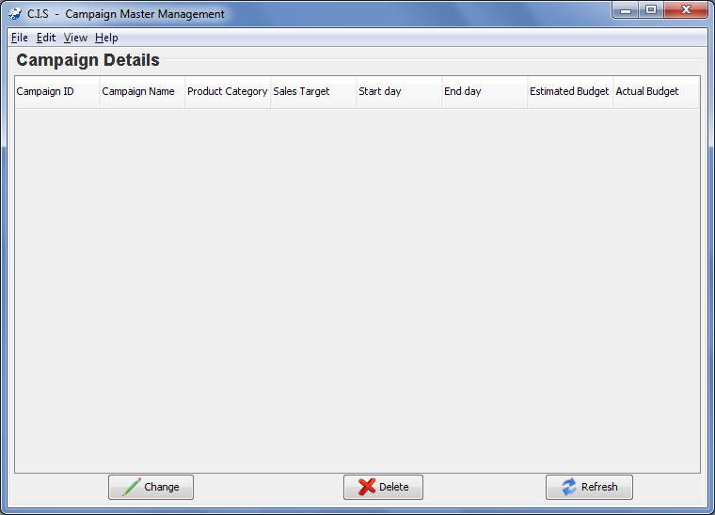

Campaign Master Form

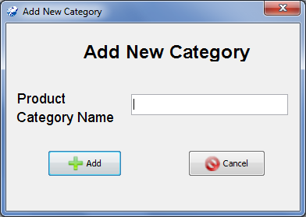

Add New Category Form

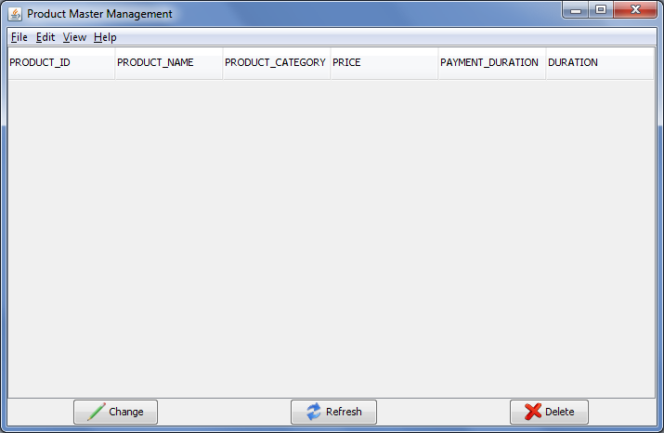

Product Master Form
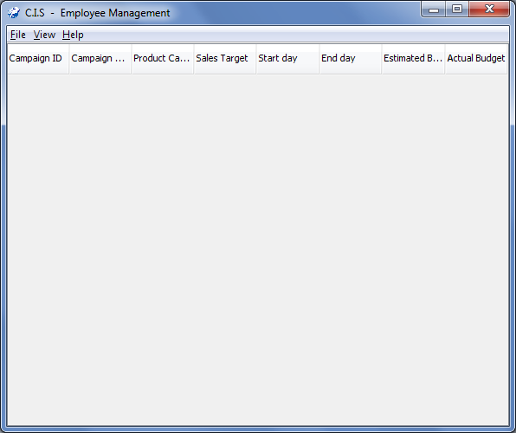

Employee Form

8.2 Format of application
- Layout and color of all forms of application is gray.
- Font of all form is Dialog
- Menu and Button have icon
- Title of each form has an icon of application

9. Task Sheet

 |  | Project Title | Activity Plan Prepared By: | Date of Preparation of Activity Plan:
No. | Task | Project Title | Activity Plan Prepared By: | Actual Start Date | Actual Days | Team Member Names | Status
01 | Requirements analysis | CIS | Nguyen Ba Dung, Tran Phan Quoc Hai, Nguyen Huu Sang |  | 4 |  | Done
02 | Design GUI | CIS |  |  | 4 | Nguyen Ba Dung, Tran Phan Quoc Hai, Nguyen Huu Sang | Done
03 | Database Design | CIS |  |  | 1 | Nguyen Huu Sang | Done
04 | Write to method get, set value of field | CIS |  |  | 2 | Nguyen Ba Dung | Done
05 | Write to Class Check | CIS |  |  | 2 | NguyencBa Dung, Tran Phan Quoc Hai | Done
06 | Write to method insert, update, delete | CIS |  |  | 3 | Nguyen Ba Dung, Tran Phan Quoc Hai, Nguyen Huu Sang | Done
07 | Write to method load data, search | CIS |  |  | 3 | Nguyen Ba Dung | Done
08 | Document action and Report | CIS |  |  | 4 | Tran Phan Quoc Hai | Done
09 | Jasper Report | CIS |  |  | 1 | Tran Phan Quoc Hai | Done
10 | User Guide | CIS |  |  | 2 | Tran Phan Quoc Hai | Done
11 | Testing | CIS |  |  | 2 | Nguyen Huu Sang | Done
12 | Debug | CIS |  |  | 1 | Nguyen Ba Dung | Done
13 | Packing software | CIS |  |  | 1 | Nguyen Huu Sang | Done

6. Checklist

6.1 Checklist of Validation

No. | Testing parameter | Validated (yes/no)
01 | Administrator can create a new user to enter the applications? | YES
02 | Distinguish users and administrators | YES
03 | User can change password | YES
04 | Campaign Master can create new Campaign in application | YES
05 | Product Master can create new Product in application | YES
06 | User can edit profile | YES
07 | Admin can export report | YES
08 | Campaign Master can create product category

6.2. Submission checklist

No. | Details | Yes | No | NA | Comment
01 | the users table to login the application after validation is performed on the user name and Password | Yes
02 | The application has icon in the title, button and menu | Yes
03 | the GUI of application friendly | Yes



Project Title : Campaign Information System

A. System Requirement

Sr. | Item | Description
1 | OS | Window XP
2 | Database | Microsoft SQL Server 2005
3 | Fonts | Unicode
4 | Programing Language | Java
5 | Editor | Eclipse

B. Installation Step

1. Install Microsoft SQL Server 2005
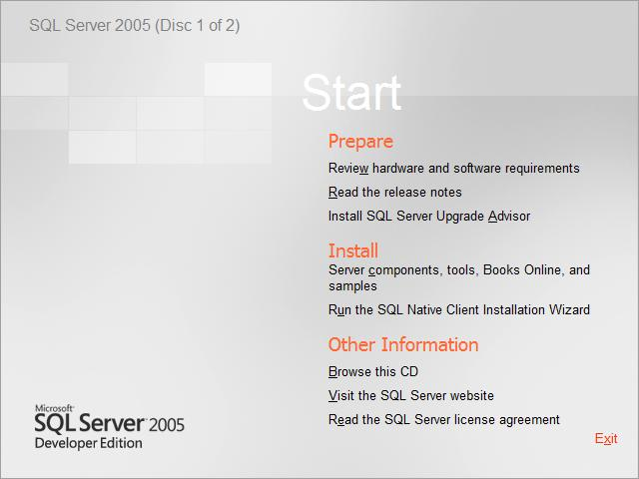

Click to install the “Server Component,tool,Books Online and samples”.

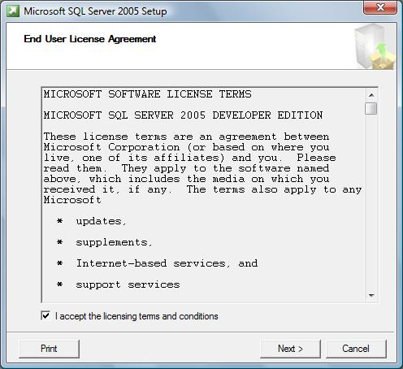

Accept the “End User License Agreement”. Click Next.

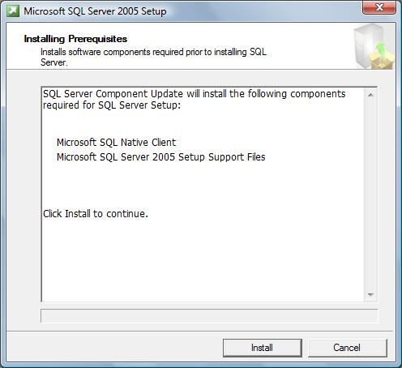

The Installing Perpetuates window will appear. Click Install

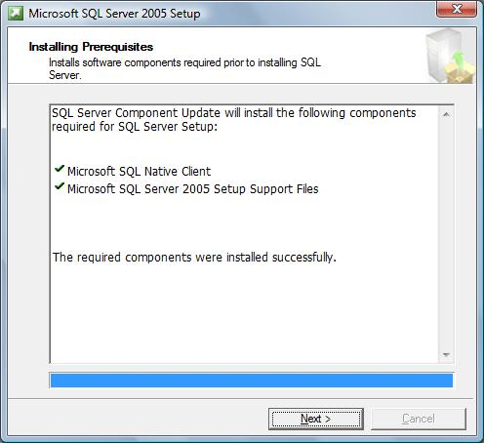

Then click Next to continue

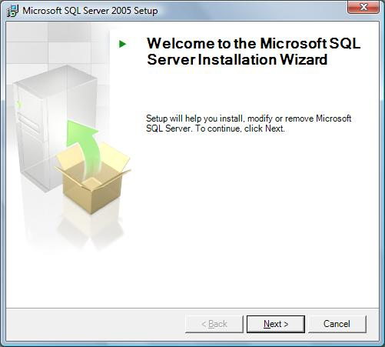

The SQL Server Installation Wizard will now appear. Click Next.
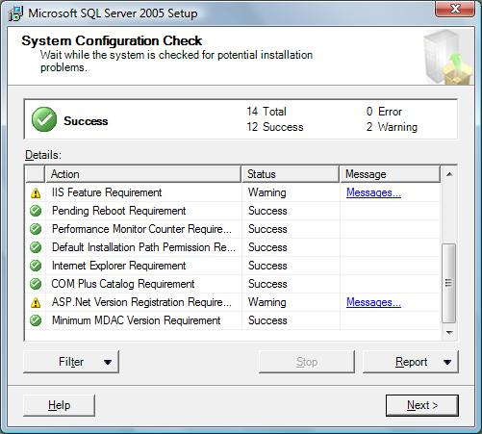

The System Configuration Check window will appear. The status of
each should indicate a status of “Success”. If everything checks out, click Next.

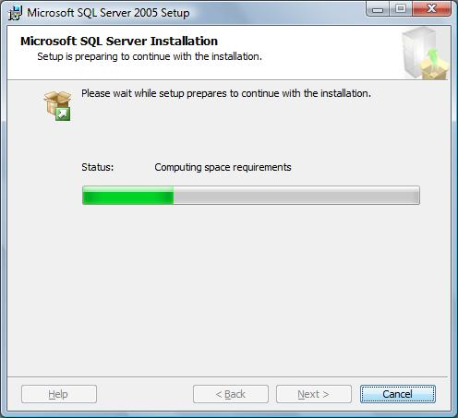

The SQL Server installation will begin to prepare the installation.
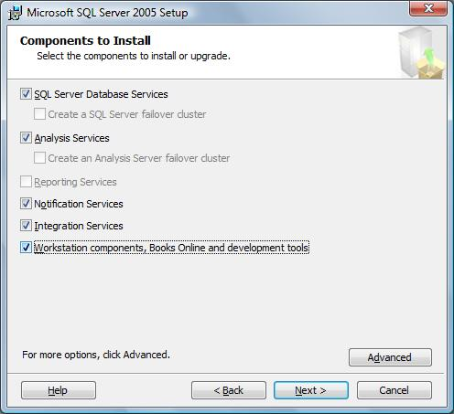

Check the followings boxes when the Components to install window appears.
Click Next when finished.

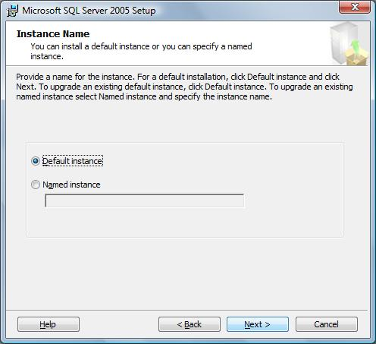

When the “Instance Name” window appears, be sure that
“Default Instance” is selected and click Next.

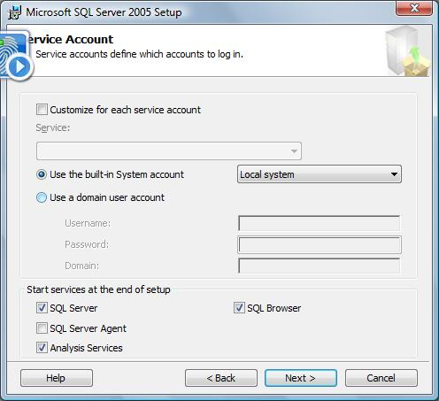

On the “Service Account” window, please select the option for “Use the built-in System account”. Be sure that “Local System” is selected. Click Next when finished.

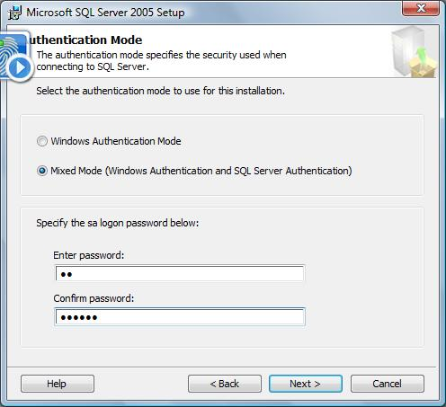

Select the “Mixed Mode” option on the “Authentication Mode” window.
At this point you may specify an sa logon and password: 123456.
Leave it blank. Click Next when finished.

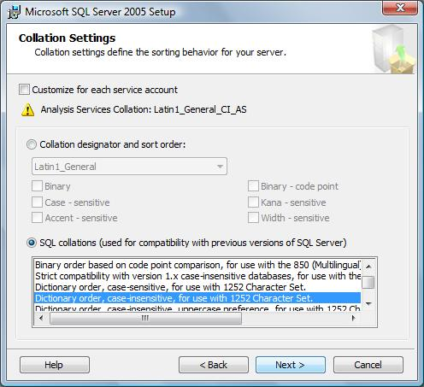

For the “Collation Settings” window, please select the option for “Dictionary order, case-insensitive, accent-insensitive, for use with 1225 Character Set”
. Click Next when finished.

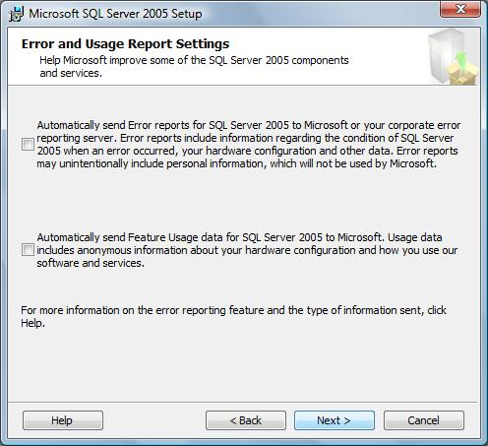

The Error and Usage Report Settings windows will appear, if you wish to send info to Microsoft, select each item, otherwise, please click Next to continue
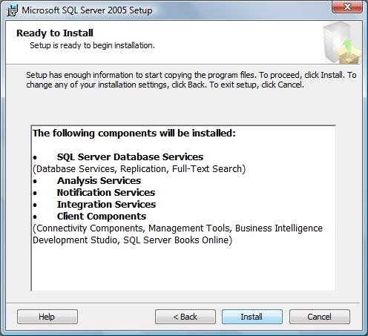

The Ready to Install window will appear. Review the components getting installed and click the Next button to continue.

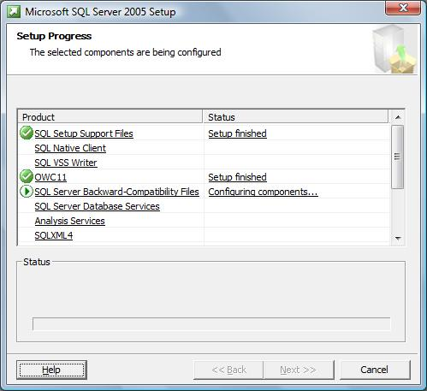

The “Setup Progress” window will appear. This will take several minutes to finish.
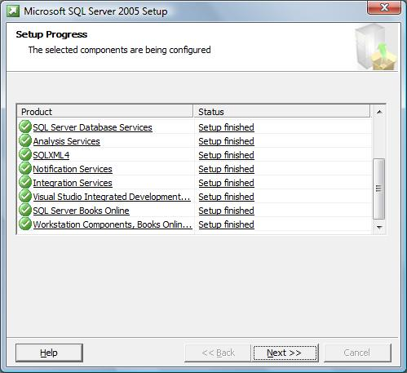

When the setup finishes, each status should indicate that the “Setup Finished”. Click Next to continue.
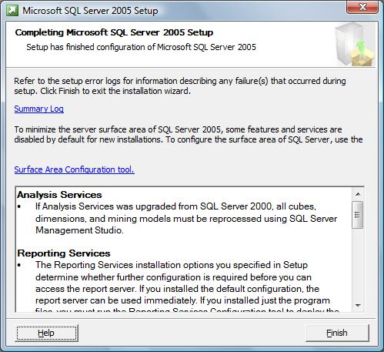

When completed, the “Completing Microsoft SQL Server 2005 Setup” window will appear. Review the services installed and click Finish.

2. Configuring MS SQL Server 2005:
To enable using application, you must config MS SQL Server 2005.At first, you configure “port”
-Select Start menu - Microsoft SQL Server 2005\Configuration Tools\SQL Server Configuration Manager
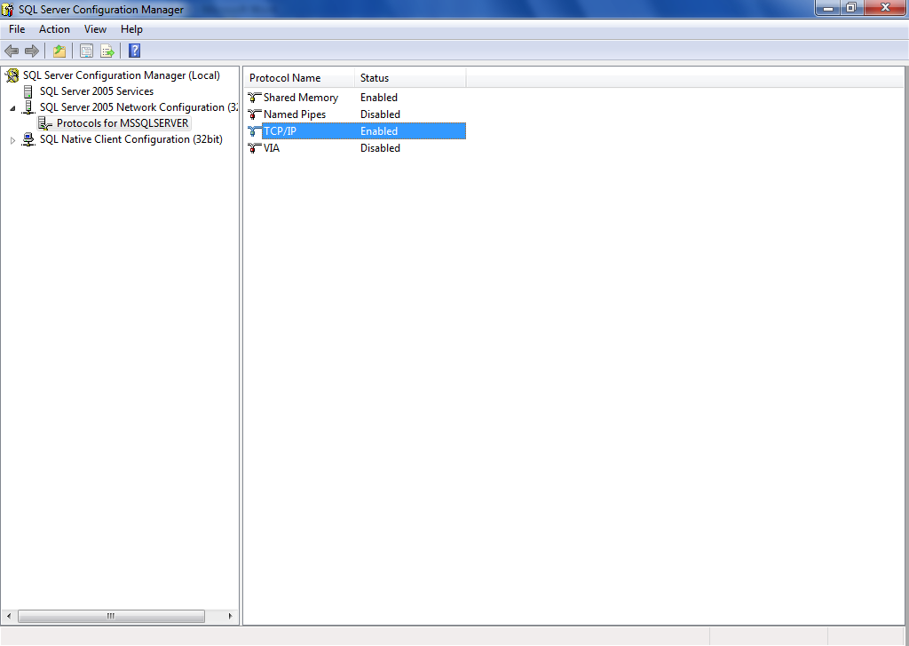

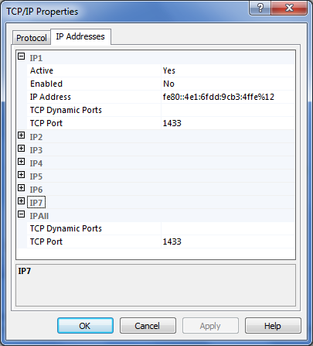

Set TCP Port : 1433
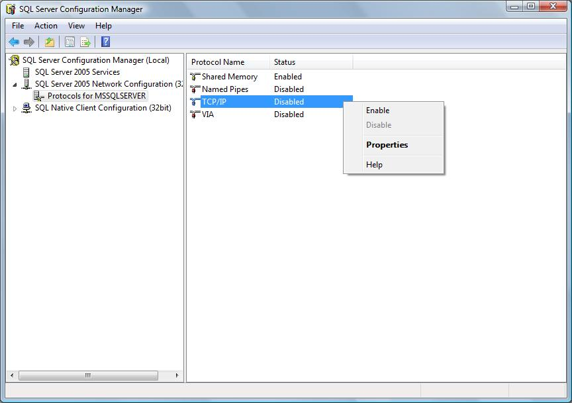

Right click on TCP/IP choose Enable
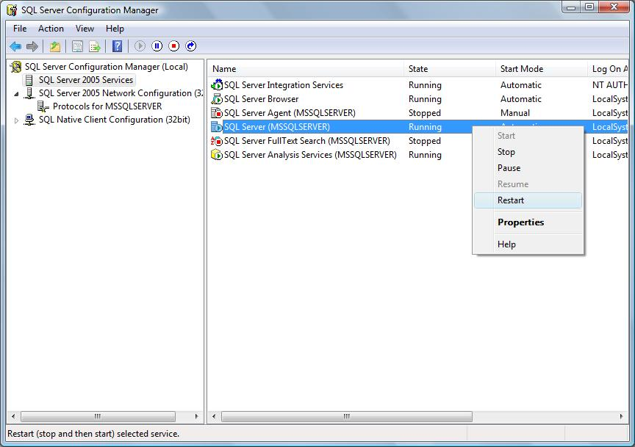

Choose SQL Server 2005 Services in left windows and right click on SQL Server (MSSQLSERVER) choose Restart

3. Install Java Development Kit (JDK 1.6)

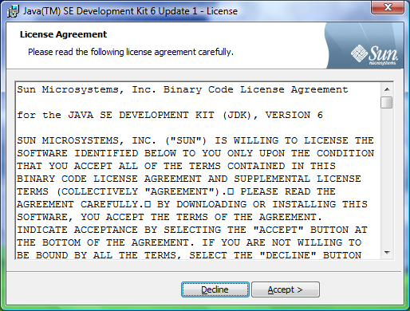

Choose Accept to setup

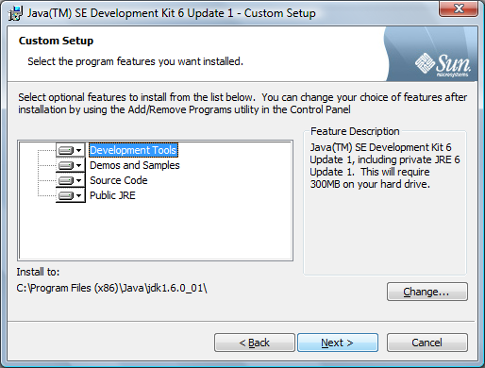

Click Next to continue

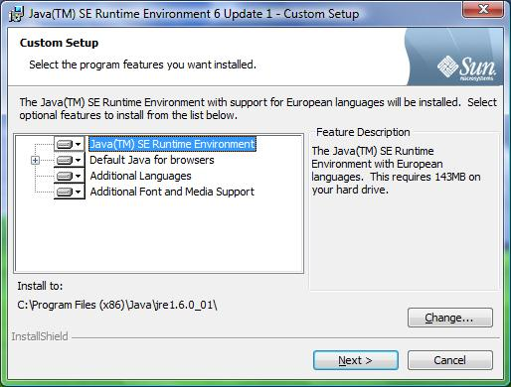

Click Next to continue

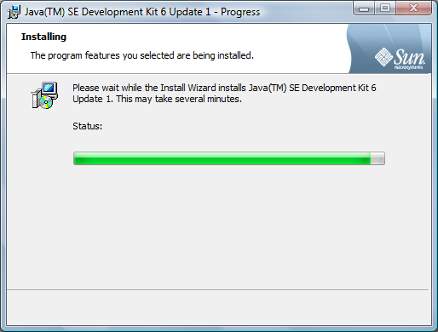

The Jdk installation will begin to prepare the installation.

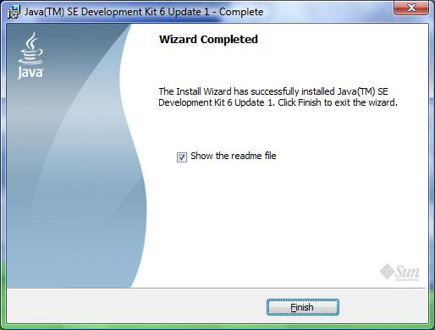

Click Finish to complete

4. Setup Database

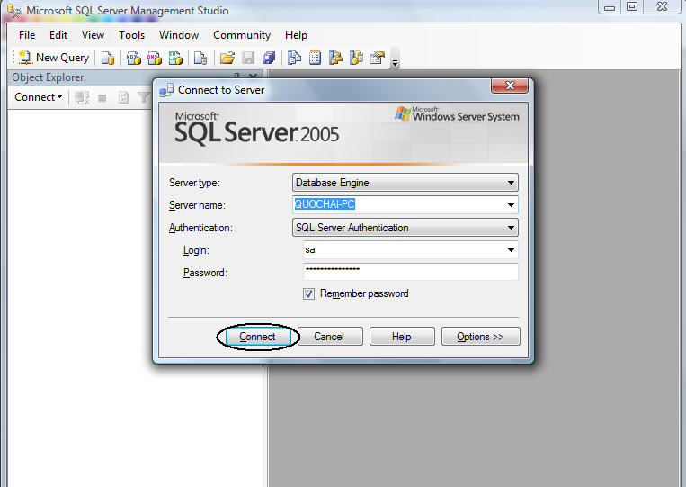

Field Authentication: choose SQL Server Authentication
Field Login: input “sa”
Field Password: input “123456”
Then click Connect
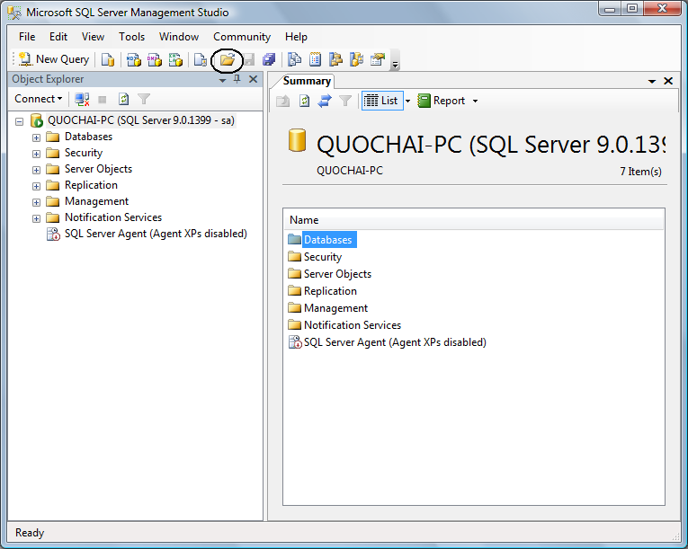

Press icon Open File or use Ctrl + O to open the file query

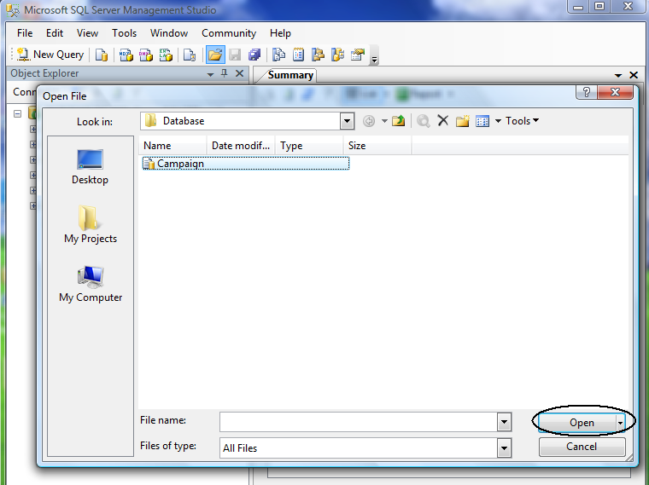

Browse to file SQL query in the project folder/Database/Campaign file
then click Open
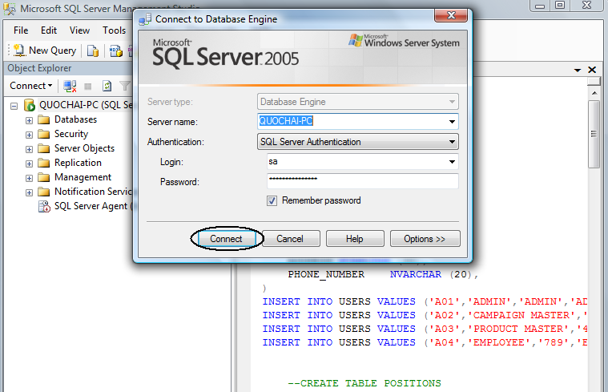

Click Connect to continue

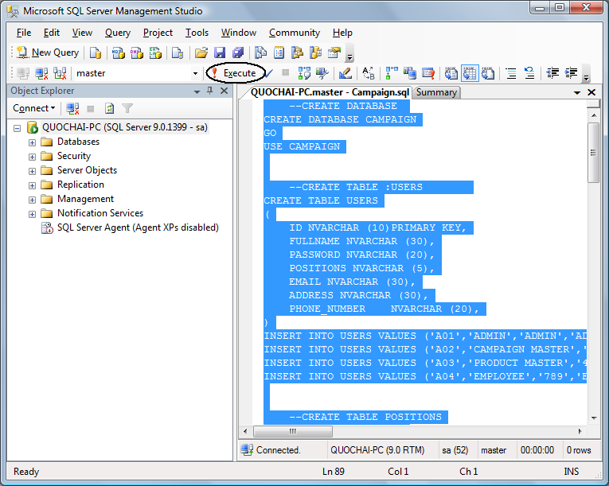

Select all (Ctrl +A) then press F5 or click Execute

5. Usage project

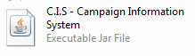

Double click on icon C.I.S – Campaign Information System to run program

And the introdution screen will be appeared

